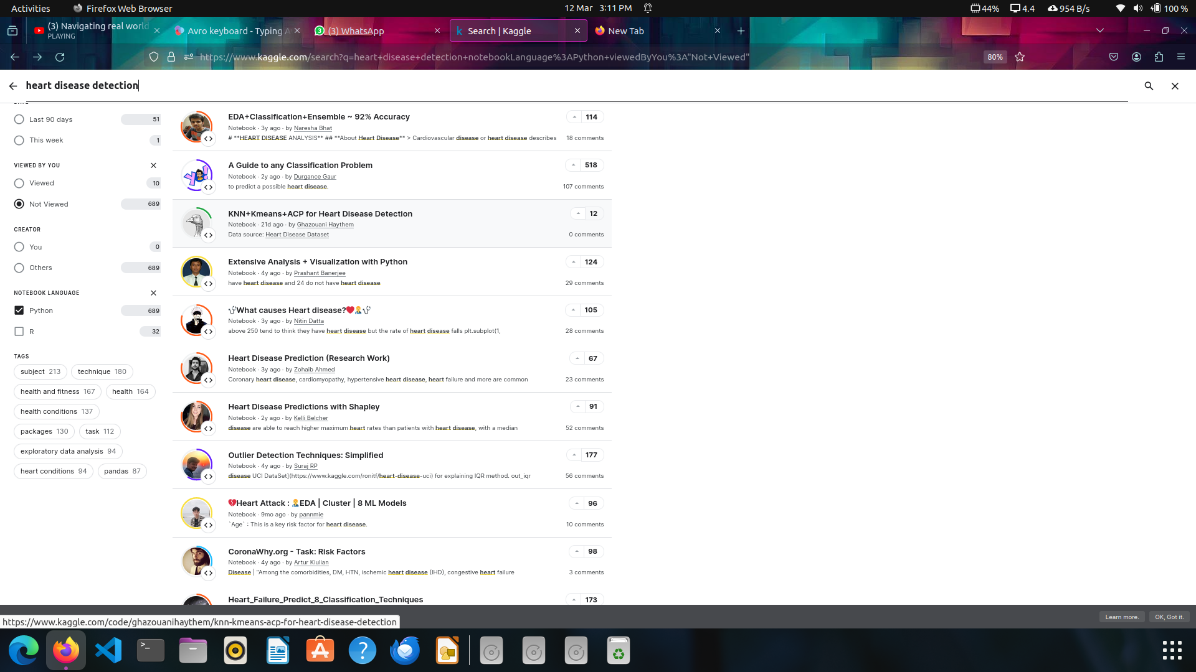

This is a good notebook from kaggle : <https://www.kaggle.com/code/nareshbhat/eda-classification-ensemble-92-accuracy>

This notebook uses these machine learning models. So it is good to learn about them : 